REPORT ON THE ISLAMIC MEDICAL ASSOCIATION OF NIGERIA (IMAN) VVF CAMPS
INTRODUCTION
Vesico-Vaginal Fistula (VVF) is defined as an abnormal connection between the bladder and the vagina. It is usually caused by prolonged obstructed labour which leads to a hole in the bladder connecting it to the vagina leading to continuous leakage of urine. The treatment of this condition is usually surgery. There are 2 million women globally suffering from VVF with 50,000-100,000 new cases each year and 40% of them are in Nigeria.
These patients are usually abandoned by their husbands, family and community and becomes a destitute, some resort to prostitution for survival. Unfortunately, they are MOSTLY MUSLIM WOMEN OF LOW SOCIO-ECONOMIC STATUS FROM NORTHERN NIGERIA.
METHODOLOGY
The Islamic Medical Association of Nigeria (IMAN) in collaboration with the JAIZ Charity and Development Foundation, the Wife of the Governor of Niger State, Dr. Amina Abubakar Sani Bello, and Engender Health (Fistula Care) held a Vesico Vaginal Fistula (VVF) Repair camp in July 2016 as part of the pre-conference activities of the IMAN- FIMA International conference which held in Abuja. JAIZ Charity Foundation donated the sum of Five Million Naira only (N5, 000, 000.00) ($14,285.7) to IMAN for the repair of one hundred patients. Dr. Amina Abubakar Sani Bello donated the sum of One Million Naira only (N1, 000, 000.00) ($2857.1). Engender Health brought the VVF Surgeons. Funds were used for honorarium, accommodation, feeding and transportation of the surgeons, provision of consumables for the surgery, provision of diesel for the generator during surgeries, feeding of patients together with one relative three times daily throughout the period of admission, surgery and hospital stay and transportation cost for patients and relatives. Four other camps were held at the Maryam Abacha VVF Hospital, Sokoto, Sokoto State in December 2016, February, May and November 2017. The first camp was part of the celebration of the 10-year anniversary of the Sultan and the fourth camp was in collaboration with the Society of Gynaecology and Obstetrics of Nigeria (SOGON).
RESULTS
A total of 117 patients from Sokoto, Kebbi, Niger, Kano, Zamfara and Kogi States were operated as seen below. Both Muslim and non- Muslim women benefitted from the surgeries. They were mostly poor rural women with no financial, family or social support.
Table 1: Patients Profile
 |  | NUMBER OF PATIENTS |  |  |  |  | TOTAL
 | STATES | SABON WUSE | SOKOTO 1 | SOKOTO 2 | SOKOTO 3 | SOKOTO 4
1. | SOKOTO | 0 | 24 | 27 | 2 | 19 | 72
2. | ZAMFARA | 8 | 2 | 4 | 2 | 0 | 16
3. | KEBBI | 0 | 1 | 4 | 3 | 3 | 11
4. | NIGER | 9 | 1 | 0 | 2 | 3 | 15
5. | KANO | 2 | 0 | 0 | 0 | 0 | 2
6. | KOGI | 1 | 0 | 0 | 0 | 0 | 1
 | TOTAL | 20 | 28 | 35 | 9 | 25 | 117

Figure 1: Percentage of Patients From States

Figure 2: Success Rate

SABON WUSE VVF CAMP
S/No | Name | Age | Parity | LGA | Years of Diagnosis | Previous repair | Complication | Outcome | Remarks
1. | Joyce Yusuf | 20 | 1, not alive | Tafa  (Niger State) | 1 year | No | Nil | DRY | Discharged
2. | Esther Ishaku | 32 | 6, 6 alve | Suleja  (Niger State) | 7 months | No | UTI | DRY | Discharged
3. | Aisha Saminu | 19 | 0 | Kontagora  (Niger State) | 3 months | No | Endometritis | DRY | Discharged
4. | Amina Salihu | 50 | 5, 1 alive | Mokwa  (Niger State) | 20 years | No | Nil | DRY | Discharged
5. | Hauwa ‘u Imam | 40 | 10, 7 alive | Kontgora (Niger State) | 3 months | No | Nil | DRY | Discharged
6. | Jamila Lawali | 27 | 1, not alive | Gusau  (Zamfara State) | 3 months | 4 times | Broken down repair | WET | For repeat repair
7. | Rabi Hamisu | 13 | 0 | Gusau  (Zamfara State) | Since birth | No | Urethral catheter treatment, | DRY | Discharged
8. | Adama Lawal | 40 | 7, 3 alive | Gusau  (Zamfara State) | 19 years | No | Broken down repair | WET | For repeat repair
9. | Saudatu Sani | 50 | 12, 7 alive | Gusau (Zamfara State) | 35 years | No | Anaemia, 2 pints transfused | DRY | Discharged
10. | Halima Yunusa | 50 | 8, 8 alive | Koton Karfe (Kogi State) | 20 years | No | Stress incontinence | DRY | Bladder drill
11. | Suwaiba Rabiu | 20 | 1, not alive | Gusau (Zamfara State) | 6 months | Once | Nil | DRY | Discharged
12. | Balkisu Umar | 18 | 1, not alive | Gusau (Zamfara State) | 4 months | No | Nil | DRY | Discharged
13. | Inno Sani | 27 | 2, none alive | Gusau (Zamfara State) | 9 years | once | Residual fistula | WET | Repair later
14. | Saudatu Bello | 35 | 0 | Gusau (Zamfara State) | 28 years | 9 times | Nil | DRY | Discharged
15. | Shamsiyya Alhassan | 35 | 1, not alive | T/ Wada (Kano State) | 13 | 6 times | No access, repair not done | DRY | Nil
16. | Zainab Muhammed | 28 | 7, 4 alive | T/ Wada (Kano State) | 2 months | Nil | Stress incontinence | DRY | Discharged
17. | Hajiya Tambaya | 40 | 10, 5 alive | Sabon Wuse (Niger State) | 12 years | 2 times | Residual fistula | WET | Repeat
18. | Hannatu Luka | 45 | 9, 3 alive | Mokwa (Niger State) | 3 months | Nil | Nil | DRY | Discharged
19. | Medinat Shuaibu | 32 | 1, not alive | Minna Niger State) | 2 years | 2 times | Failed repair | WET | Discharged
20. | Habiba Abbas | 40 | 11, 5 alive | Tafa (Kaduna State) | 3 years | Nil | Nil | DRY | Discharged
S/No | Name | Age | No Of Children alive | LGA | Years of Diagnosis | Previous repair | Complication | Outcome | Remarks
1. | Amina Usman | 35 | 3 | Wamako  (Sokoto State) | 1 year | 1 | Stress Incontinence | DRY | Bladder drill
2. | Zaliha Muhammed | 20 | 0 | Baichi  (Sokoto State) | 4 years | Nil | Nil | DRY | Discharged
3. | Rabi Saminu | 20 | 1 | Achida  (Sokoto State) | 3 weeks | Nil | Nil | DRY | Discharged
4. | Luba Nasiru | 35 | 2 | Dutsin Assada (Sokoto State) | 2 months | Nil | Uretero-vaginal Fistula | WET | In Hospital
5. | Rabi Buba | 20 | 1 | Gushin Dutsi (Sokoto State) | 5 months | Nil | Nil | DRY | Discharged
6. | Jamila Jamilu | 20 | 1 | Makera  (Niger State) | 16 months | Nil | Anaemia, 2 pints transfused | DRY | Discharged
7. | Hauwa’u Muhammed | 35 | 6 | Yabo  (Sokoto State) | 1 year | Nil | Stress Incontinence | DRY | Bladder drill
8. | Hadiza Abdullahi | 18 | 0 | Bakura  (Zamfara State) | 2 months | Nil | Stress Incontinence | DRY | Bladder drill
9. | Luba Musa | 30 | 3 | Kware (Sokoto State) | 2 years | 1 | Not Closed | WET | In Hospital
10. | Aisha Lawali | 25 | 0 | Tambuwal (Sokoto State) | 1 year | Nil | Stress incontinence | DRY | Bladder drill
11. | Khadijat Mansur | 25 | 1 | Gujiya (Sokoto State) | 7 months | Nil | Nil | DRY | Discharged
12. | Hindatu Dauda | 30 | 4 | Dunbawa (Sokoto State) | 6 months | Nil | Nil | WET | In Hospital
13. | Fatima Bala | 25 | 2 | Dingyadi (Sokoto State) | 1 year | 1 | Residual fistula | WET | In Hospital
14. | Farida Kabiru | 20 | 0 | Gummi (Zamfara State) | 4 years | 1 | Nil | DRY | Discharged
15. | Lawiza Sani | 20 | 0 | Kamba (Kebbi State) | 1 year | Nil | Nil | DRY | Discharged
16. | Umaima Nasiru | 37 | 7 | Kware (Sokoto State) | 17 months | 2 | Stress incontinence | DRY | Bladder drill
17. | Safiya Abdullahi | 39 | 2 | Tsamiyan dilla (Sokoto State) | 20 years | 5 | Residual fistula | WET | Repeat surgery
18. | Fatima Hantse | 35 | 0 | Wamako (Sokoto State) | 1 year | 1 | Nil | DRY | Discharged
19. | Hauwa’u Mamman | 60 | 2 | Shuni (Sokoto State) | 27 years | 2 | Failed repair | WET | In Hospital
20. | Rukayya Ahmed | 20 | 0 | Gada (Sokoto State) | 5 years | 1 | Stress Incontinence | DRY | Bladder drill
21. | Rabi Bello | 25 | 0 | Gwadabawa (Sokoto State) | 5 years | 5 | Stress Incontinence | DRY | Bladder drill
22. | Zuwaira Nasiru | 32 | 1 | Dange Shuni (Sokoto State) | 5 years | 4 | Stress Incontinence | DRY | Bladder drill
23. | Hauwa’u Jamilu | 25 | 0 | Kware (Sokoto State) | 6 years | 4 | Stress Incontinence | DRY | Bladder drill
24. | Rukayya Saminu | 15 | 0 | Kware (Sokoto State) | 4 years | 2 | Stress Incontinence | DRY | Bladder drill
25. | Aisha Abubakar | 30 | 0 | Gidan Madi (Sokoto State) | 7 years | 3 | Stress Incontinence | DRY | Bladder drill
26. | Maryam Isah | 16 | 0 | Gwadabawa  (Sokoto State) | 1 year | 0 | Nil | DRY | Discharged
27. | Lubabatu Umar | 37 | 4 | Shuni (Sokoto State) | 3 weeks | 1 | Residual fistula | WET | Repeat repair
28. | Aisha Buba | 25 | 4 | Badawa (Sokoto State) | 4 years | 1 | Nil | DRY | Discharged

FIRST VVF CAMP SOKOTO

SECOND VVF CAMP SOKOTO
S/No | Name | Age | No Of Children alive | LGA | Years of Diagnosis | Previous repair | Complication | Outcome | Remarks
1. | Halima Garba | 20 | 1 | Gada  (Sokoto State) | 4 years | None | Nil | DRY | Bladder drill
2. | Aisha Mujtaba | 16 | 0 | Durbawa  (Sokoto State) | 2 years | Nil | Residual Fistula | WET | In Hospital
3. | Aisha Haliru | 20 | 0 | Shaifawa  (Sokoto State) | 8 months | Nil | Nil | DRY | Discharged
4. | Zuwaira Ilyasu | 35 | 3 | Llella (Sokoto State) | 3 years | Nil | Nil | DRY | Discharged
5. | Zuwaira Musa | 25 | 0 | Jar Kuka (Sokoto State) | 1 year | Nil | Nil | STRESS INCONTINENCE | Discharged
6. | Tahara Musa | 22 | 0 | Dankurmi  (Sokoto State) | 4 years | Nil | Residual Fistula | WET | In Hospital
7. | Maryam Isah | 25 | 0 | Dogon Daji  (Sokoto State) | 1 year | 1 | Nil | DRY | Discharged
8. | Hauwa’u Muhammed | 45 | 2 | Gumi (Zamfara State) | 1 year | Nil | Stress Incontinence | DRY | Bladder drill
9. | Rabi Liman | 35 | 7 | Danden Mahe (Sokoto State) | 3 years | Nil | Nil | DRY | Discharged
10. | Kullu Ummaru | 35 | 6 | Kamba (Kebbi State) | 10 months | Nil | Nil | DRY | Discharged
11. | Hauwa’u Musa | 20 | 6 | Augi (Kebbi State) | 5 years | 1 | Residual Fistula | WET | In Hospital
12. | Hindatu Abubakar | 10 | 0 | Kware (Sokoto State) | 5 years | Nil | Fistula was from an accident (fall of a building on the patient) | DRY | Discharged
13. | Aa’i Sahabi | 40 | 5 | Katami (Sokoto State) | 2 year | 1 | Stress Incontinence | DRY | Bladder Drill
14. | Asma’u Abubakar | 30 | 1 | Wamako (Sokoto State) | 1 year | 1 | Residual Fistula | WET | In Hospital
15. | Safiya Danlami | 22 | 0 | Salame (Sokoto State) | 2 months | Nil | Residual Fistulal | WET | In Hospital
16. | Safiya Ila | 40 | 7 | Kware (Sokoto State) | 18 years | 4 | Stress Incontinence | DRY | Bladder drill
17. | Hadiza Musa | 18 | 0 | Gwaranyo(Sokoto State) | 3 weeks | Nil | Stress Incontinence | DRY | Bladder Drill
18. | Luba Muhammed | 18 | 0 | Gidan Gamba (Sokoto State) | 1 year | Nil | Nil | DRY | Discharged
19. | Fatima Muhammad | 35 | 0 | Bodinga (Sokoto State) | 18 years | 4 | Nil | DRY | Discharged
20. | Sadiya Garba | 18 | 0 | Silame (Sokoto State) | 3 years | 2 | Nil | DRY | Discharged
21. | Hauwa’u Ummaru | 24 | 0 | Wamakko (Sokoto State) | - | - | Nil | DRY | Discharged
22. | Suwaiba Abubakar | 30 | 3 | Dange Shuni (Sokoto State) | 1 year | Nil | Nil | DRY | Discharged
23. | Meri Mallam Isuhu | 30 | 0 | Silame (Sokoto State) | - | - | Recto- Vaginal Fistula | WET | In Hospital
24. | Fatima Abubakar | 20 | 0 | Tureta (Sokoto State) | 3 years | 2 | Residual Fistula | WET | In Hospital
25. | Aisha Aliyu | 21 | 0 | Tureta (Sokoto State) | 2 years | 1 | Nil | DRY | Discharged
26. | Nasara Haruna | 40 | 0 | Gwadabawa  (Sokoto State) | 10 year | 0 | Stress Incontinence | DRY | Bladder drill
27. | Issa Ummaru | 50 | 4 | Gurunji (Sokoto State) | 4 years | 1 | Nil | DRY | Discharged
28. | Nana Dalhatu | 40 | 2 | Shagari (Sokoto State) | 1 year | 0 | Stress Incontinence | DRY | Bladder Drill
29. | Saudatu Bello | 35 | 4 | Gusau (Zamfara State) | 3 years | 1 | Nil | DRY | Discharged
30. | Luba Ibrahim | 40 | 2 | Durbawa (Sokoto State) | 3 years | 2 | Residual Fistula | WET | In Hospital
31. | Jamila Aminu | 38 | 0 | Bankanu (Sokoto State) | 10 years | 4 | Stress Incontinence | DRY | Bladder drill
32. | Luba Abubakar | 23 | 0 | Shinkafi (Sokoto State) | - | - | Stress Incontinence | DRY | Bladder drill
33. | Kullu Aliyu | 30 | 0 | Farfaru (Sokoto State) | - | - | Stress Incontinence | DRY | Bladder drill
34. | Amina Muhammed | 30 | 0 | Durbawa Sokoto State) | - | - | Stress Incontinence | DRY | Bladder drill
35. | Aisha Awwwalu | 20 | 0 | Shagari (Sokoto State) | - | - | Nil | DRY | Discharged

THIRD VVF CAMP SOKOTO
S/No | Name | Age | No Of Children alive | LGA | Years of Diagnosis | Previous repair | Complication | Outcome | Remarks
1. | Hauwa M Sani | 35 | 0 | Agwara  (Niger State) |  | Nil | Nil | WET | Repeat
2. | Aisma’u Muhammad | 20 | 0 | Ribbe  (Kebbi State) |  | Nil | Nil | DRY | Discharged
3. | Aisha Labaran | 35 | 0 | Dankurmi  (Zamfara State) |  | Nil | Nil | DRY | Discharged
4. | Hadiza Armaya’u | 30 | 0 | Giri (Kebbi State) |  | Nil | Residual RVF | WET | In Hospital
5. | Habiba Salisu | 15 | 0 | Gwargawu (Zamfara State) |  | Nil |  | STRESS INCONTINENCE | Bladder drill
6. | Fadimatu Madi | 42 | 0 | Adogo mallam (Niger State) |  | Nil | Nil | DRY | Discharged
7. | Baraatu Habibu | 35 | 0 | Dan Makwarwa  (Kebbi State) |  | Nil | Nil | DRY | Discharged
8. | Aishatu Sani | 25 | 0 | Dan kurmi (Sokoto State) |  | Nil | Stress Incontinence | DRY | Bladder drill
9. | Halima B Ibrahim | 24 | 0 | Gwiwa Locust (Sokoto State) |  | Nil | Nil | DRY | Discharged

FOURTH VVF CAMP SOKOTO
S/No | Name | Age | No Of Children alive | LGA | Years of Diagnosis | Previous repair | Complication | Outcome | Remarks
1. | Shamsiyya Aminu | 19 | 0 | Gwadabawa  (Sokoto State) |  | Nil | Nil | DRY | Discharged
2. | Fatima Aliyu | 20 | 0 | Manga  (Niger State) |  | Nil | Nil | DRY | Discharged
3. | Aisha Umar | 40 | 5 | Kontagora  (Niger State) |  | Nil | Nil | DRY | Discharged
4. | Umayma Suleiman | 33 | 2 | Kontagora (Niger State) |  | Nil | Residual Incontinence | WET | In Hospital
5. | Sadiya Shehu | 22 | 0 | Issa (Sokoto State) |  | Nil | Nil | DRY | Discharged
6. | Talatu Sabo | 25 | 2 | Binji (Sokoto State) |  | Nil | Residual Incontinence | WET | In Hospital
7. | Fatima Muhammed | 19 | 0 | Wammako  (Sokoto State) |  | Nil | Nil | DRY | Discharged
8. | Asma’u Ibrahim | 25 | 0 | Kware (Sokoto State) |  | Nil | Residual Incontinence | WET | In Hospital
9. | Zara’u Ladan | 20 | 0 | Kware (Sokoto State) |  | Nil | Not closed | WET | In Hospital
10. | Luba Garba | 30 | 4 | Gwaranyo (Sokoto State) |  | Nil | Residual Incontinence | WET | In Hospital
11. | Nafisa Aliyu | 19 | 0 | Gwadabawa (Sokoto State) |  | Nil | Not Closed | WET | In Hospital
12. | Lubabatu Abdullahi | 20 | 0 | Gaada (Sokoto State) |  | Nil | Nil | DRY | Discharged
13. | Saratu Aliyu | 20 | 0 | Yaabo (Sokoto State) |  | Nil | Nil | DRY | Discharged
14. | Rabi Mutaha | 35 | 5 | Kware (Sokoto State |  | Nil | Nil | DRY | Discharged
15. | Fatima Umaru | 21 | 0 | Kware (Sokoto State) |  | Nil | Nil | DRY | Discharged
16. | Shafaatu Tasiu | 20 | 0 | Zuru (Kebbi State) |  | Nil | Nil | DRY | Discharged
17. | Basira Tukur | 20 | 2 | Arugungu (Kebbi State) |  | Nil | Nil | DRY | Discharged
18. | Saratu Isa | 20 | 0 | Kware (Sokoto State) |  | Nil | Not Closed | DRY | In Hospital
19. | Hauwa Bello | 28 | 3 | Gwandu (Kebbi State) |  | Nil | Nil | DRY | Discharged
20. | Nasira Haruna | 20 | 0 | Binji (Sokoto State) |  | Nil | Nil | DRY | Discharged
21. | Jamila Kabiru | 35 | 6 | Wammako (Sokoto State) |  | Nil | Residual Incontinence | WET | In Hospital
22. | Shafaatu Bello | 35 | 4 | Gwadabawa (Sokoto State) |  | Nil | Nil | DRY | Discharged
23. | Fatima Bala | 32 | 4 | Silami (Sokoto State) |  | Nil | Not Closed | WET | In Hospital
24. | Hajara Hamisu | 23 | 0 | Kware (Sokoto State |  | Nil | Nil | DRY | Discharged
25 | Maryam Aliyu | 25 | 0 | Kware (Sokoto State) |  | Nil | Nil | DRY | Discharged

FINANCES:
THE EXPENSES FOR THE FIVE CAMPS IN SABON WUSE AND SOKOTO ARE AS FOLLOWS:
 | ITEMS | AMOUNT
1. | Drugs and consumables (Antibiotics, Analgesics, Anaesthetic drugs and gases, Antimalarials, Haematinics, Antiemetics, Intravenous fluids, Giving sets, Canulae, Gloves, Blood transfusion,Antiseptics, etc. | N3,500,000.00
2. | Feeding patients and relatives for 21-28days | N1,120,000.00
3. | Honorarium for Fistula team | N525,000.00
4. | Transportation, Accommodation and feeding for Save Dignity Team and Co-opted members(5 in number) Sabon Wuse and Sokoto (on four occasions) | N670,000.00
5. | Display banners (Sabon Wuse and Sokoto) | N30,000.00
6. | Drivers and other Volunteers | N120,000.00
7. | Local transportation- Sabon Wuse and Sokoto (on four occasions) | N35,000.00
 | TOTAL | N6,000 000.00
A total of six million naira only (N6,000,000.00) was spent for the camps.

PICTURES IN SABON WUSE HOSPITAL, NIGER STATE
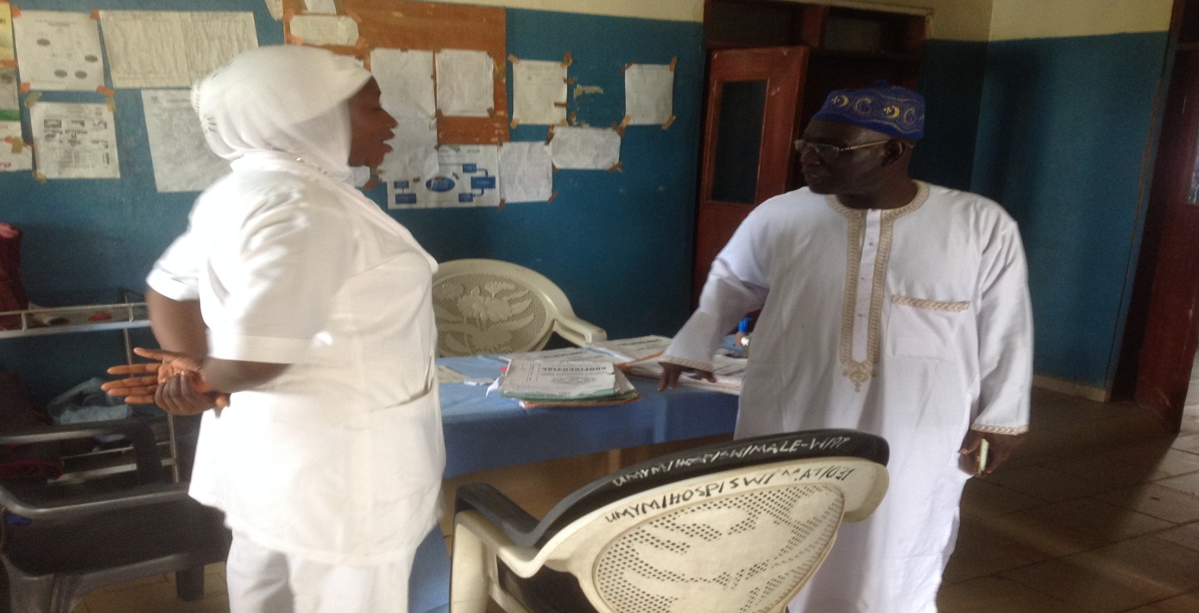
THE CHAIRMAN SAVE DIGNITY AND A NURSE IN THE VVF WARD
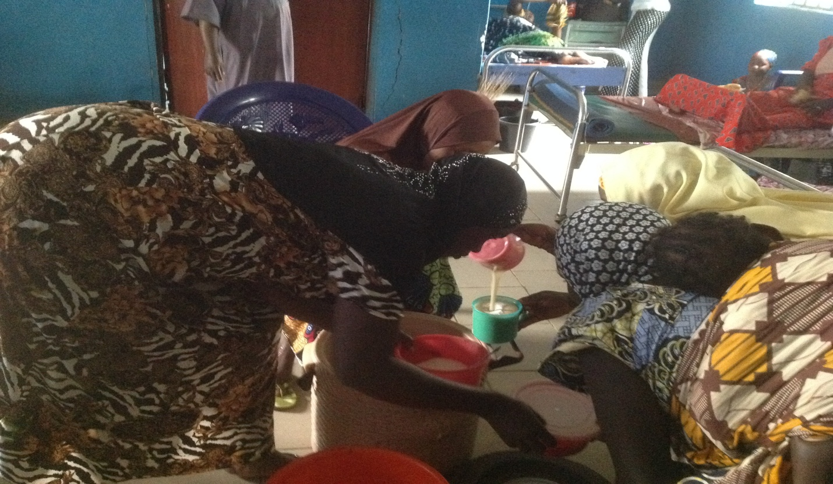
PATIENTS AND RELATIVES RECEIVING BREAKFAST
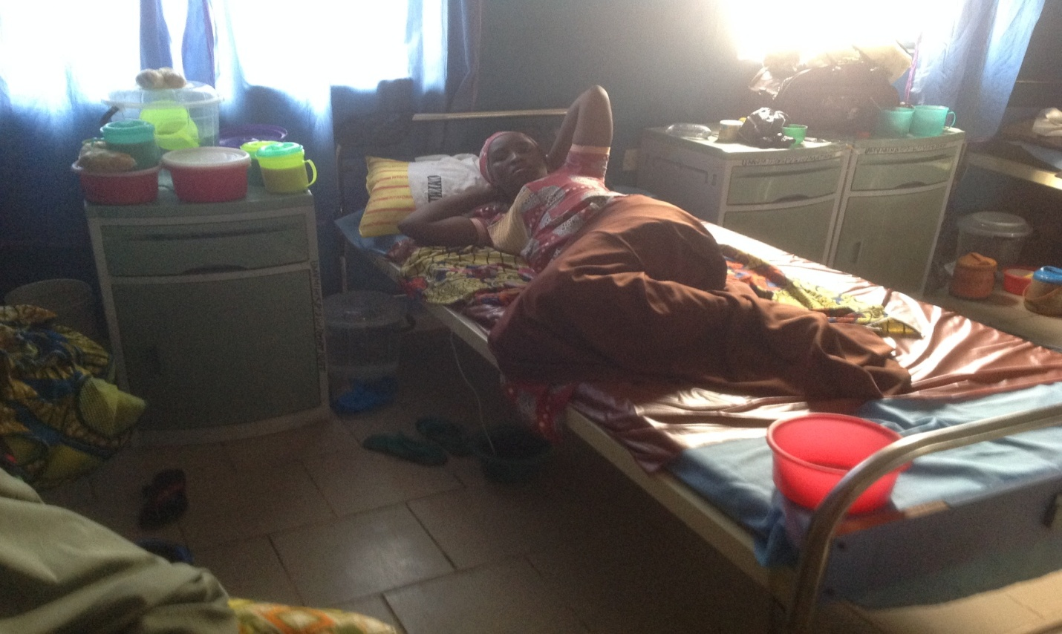
PATIENT AFTER SURGERY
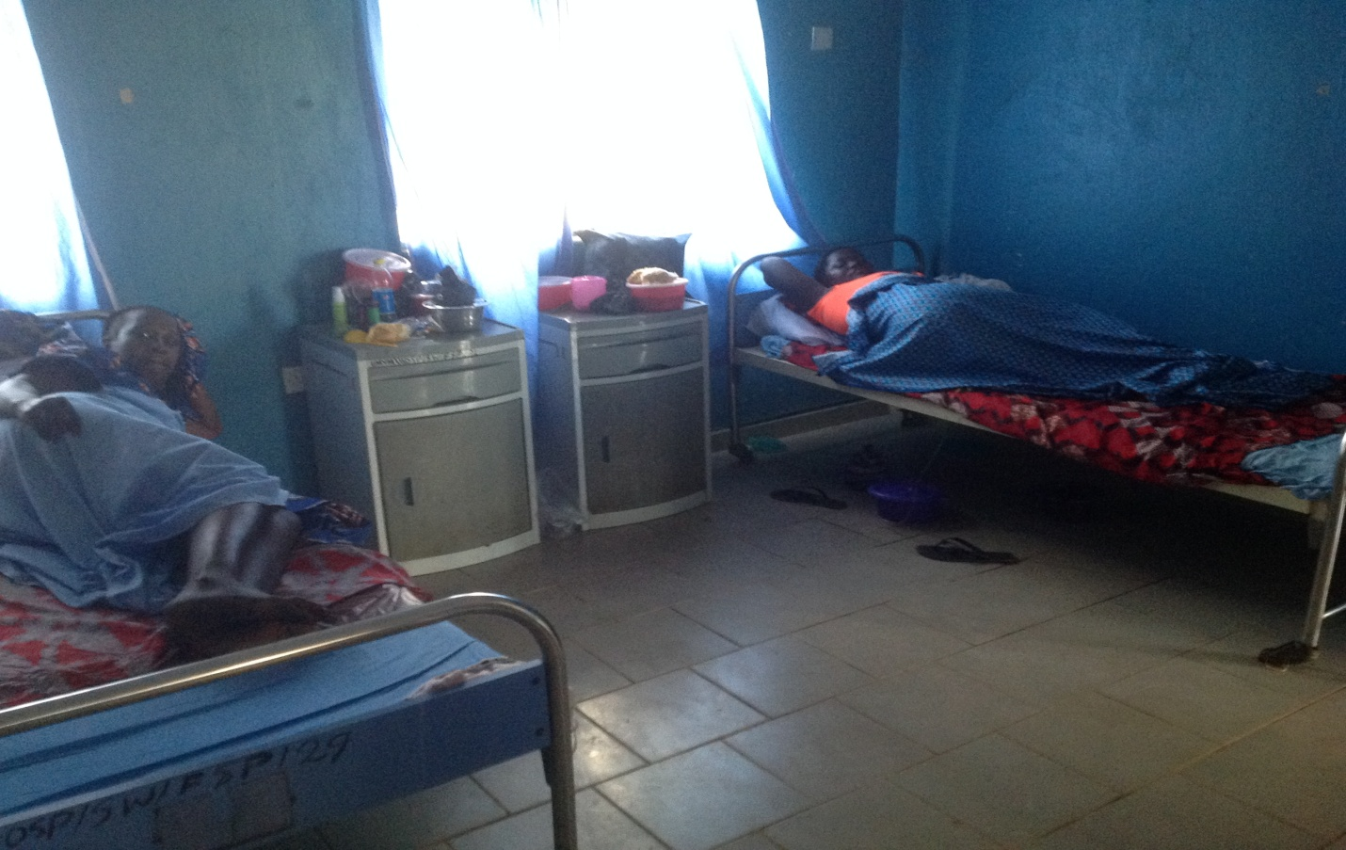
PATIENT AFTER SURGERY
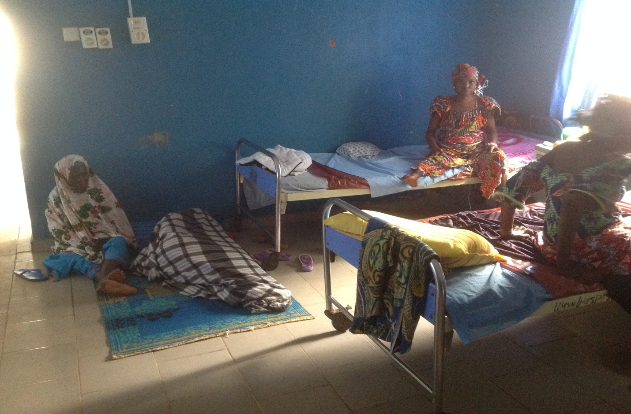
PATIENTS RECOVERING IN THE WARD
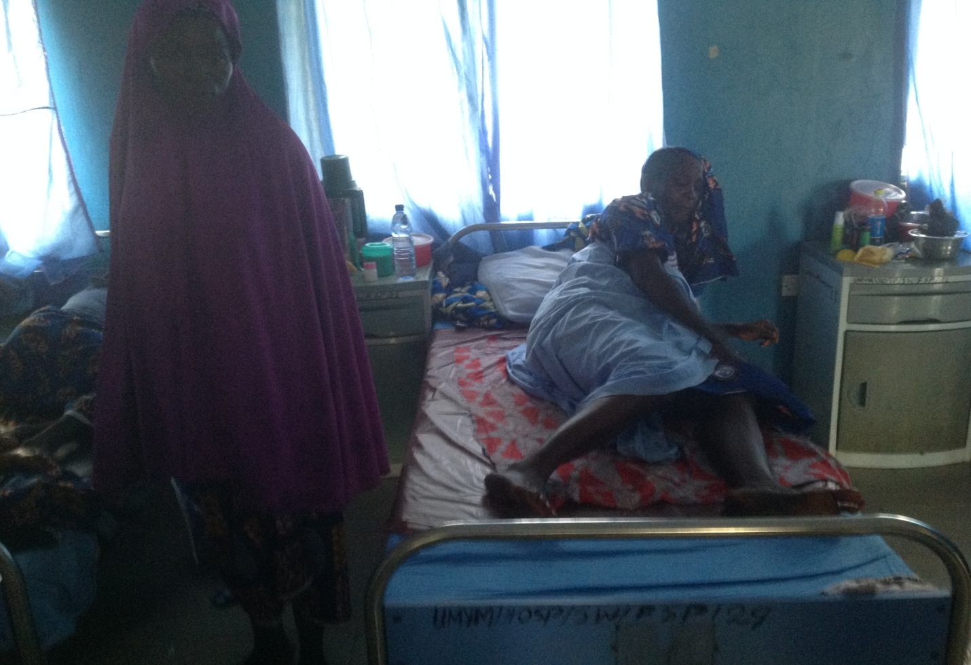
PATIENT IN THE WARD
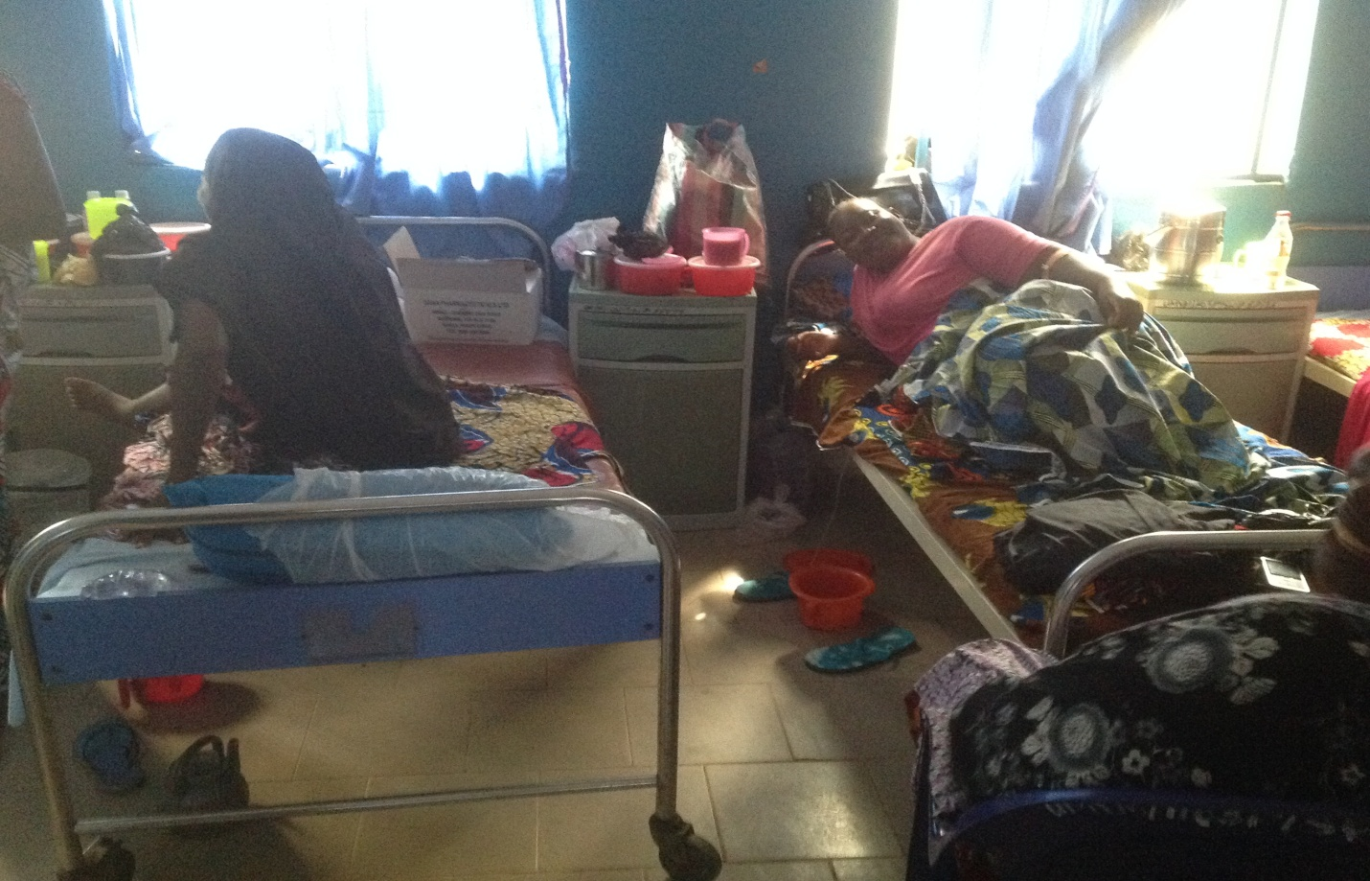
NON MUSLIM PATIENT IN THE WARD

PICTURES MARYAM ABACHA VVF HOSPITAL SOKOTO
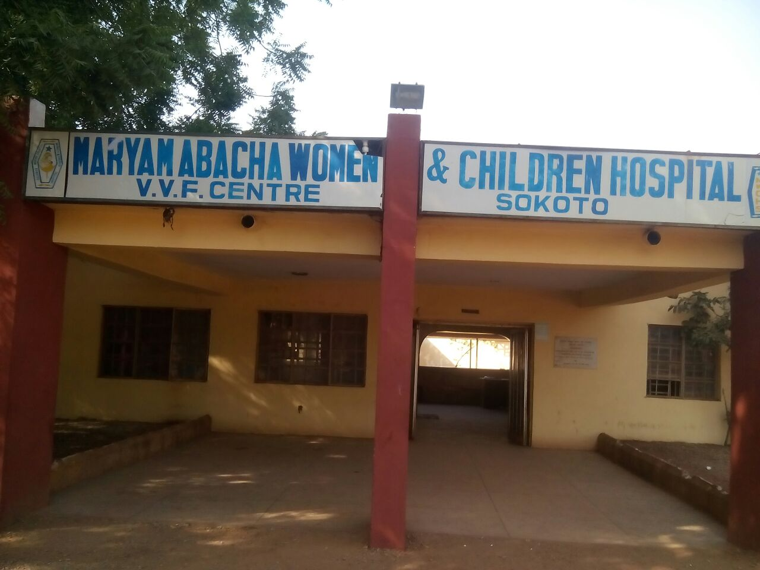
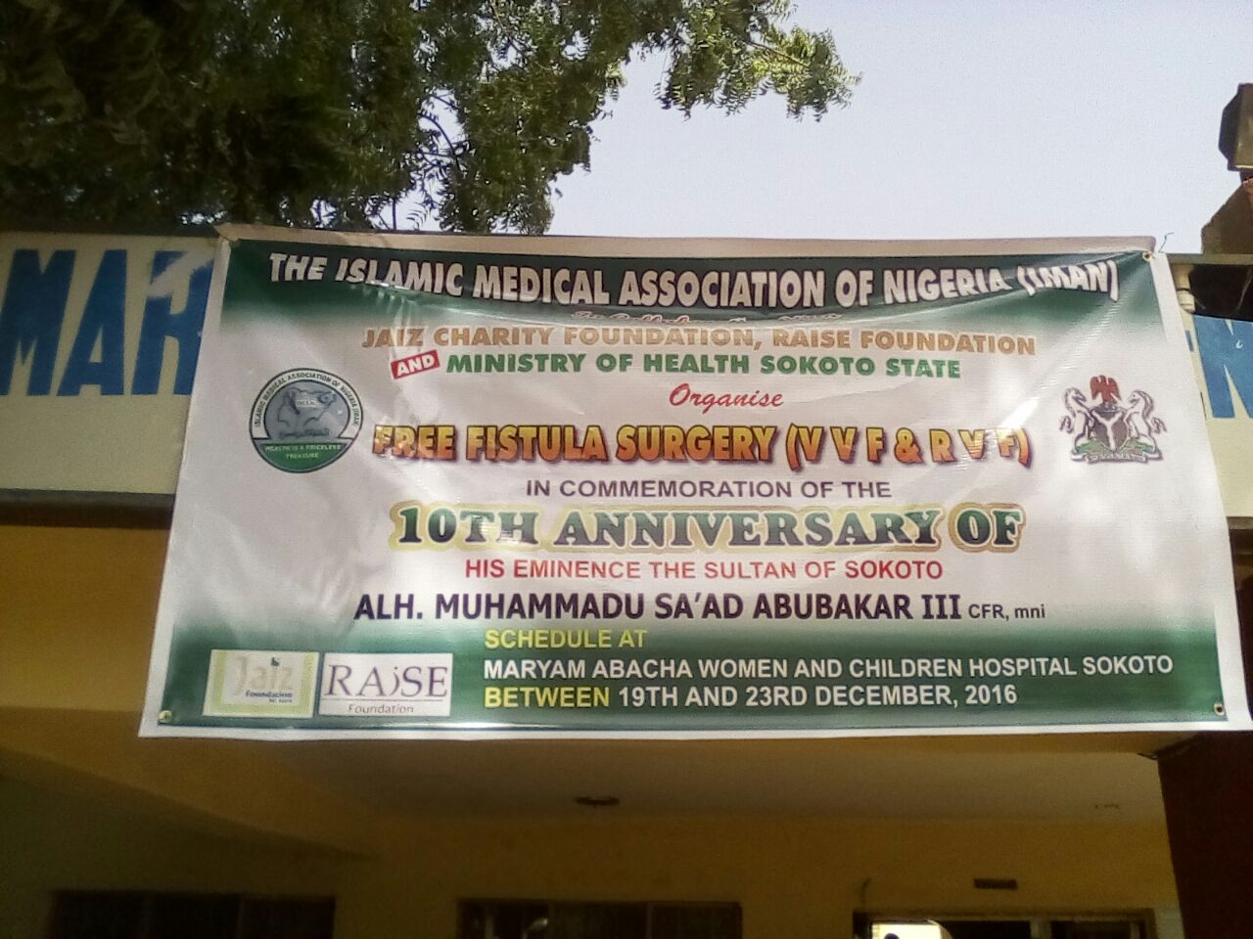

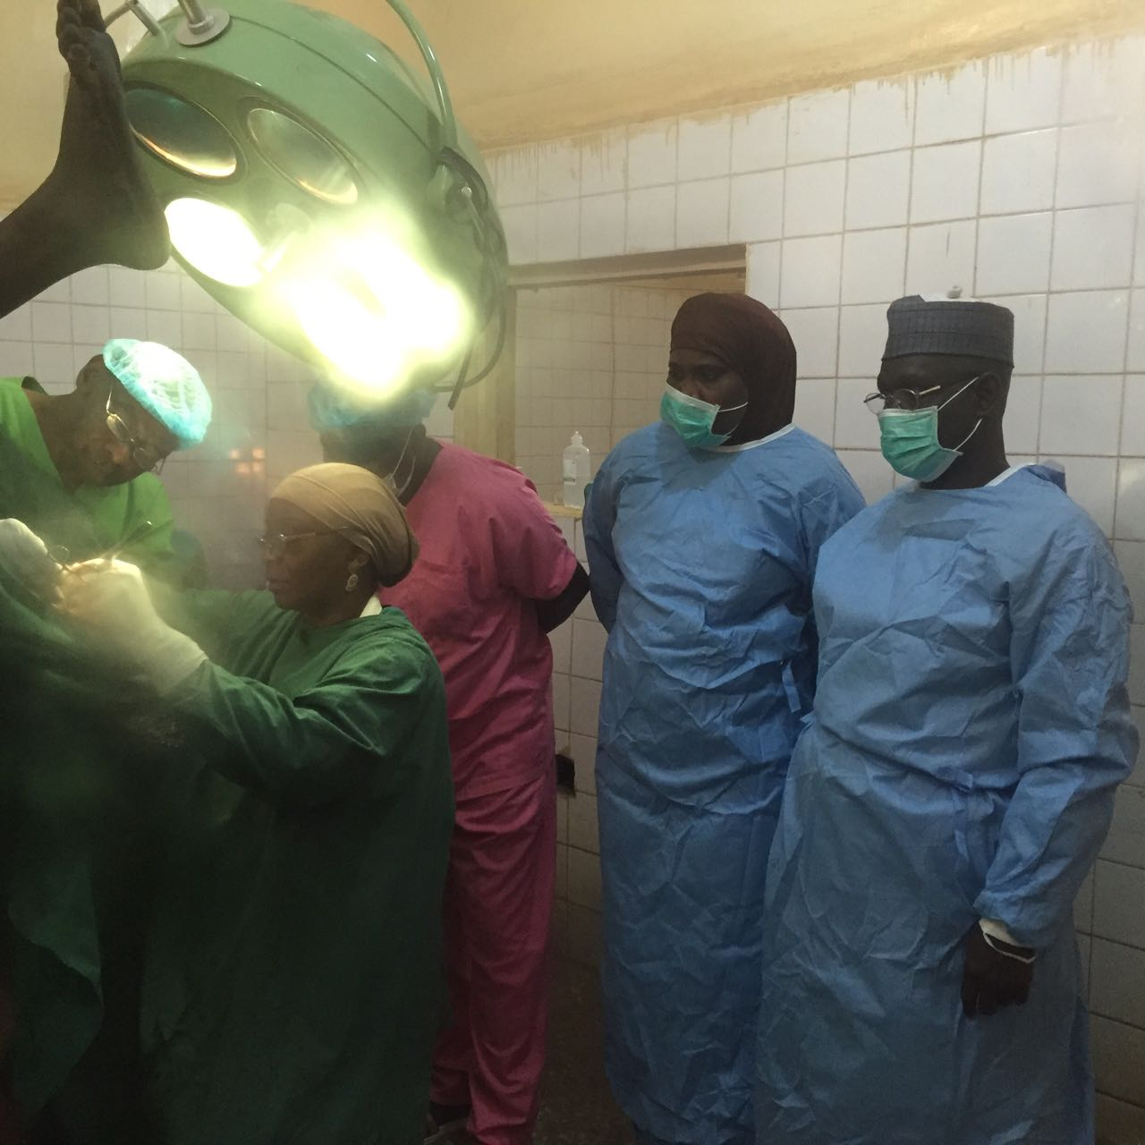
CHAIRMAN SAVE DIGNITY DR SULE, MATRON NAÍMAH, DR MAIRO AND TEAM IN THE THEATRE

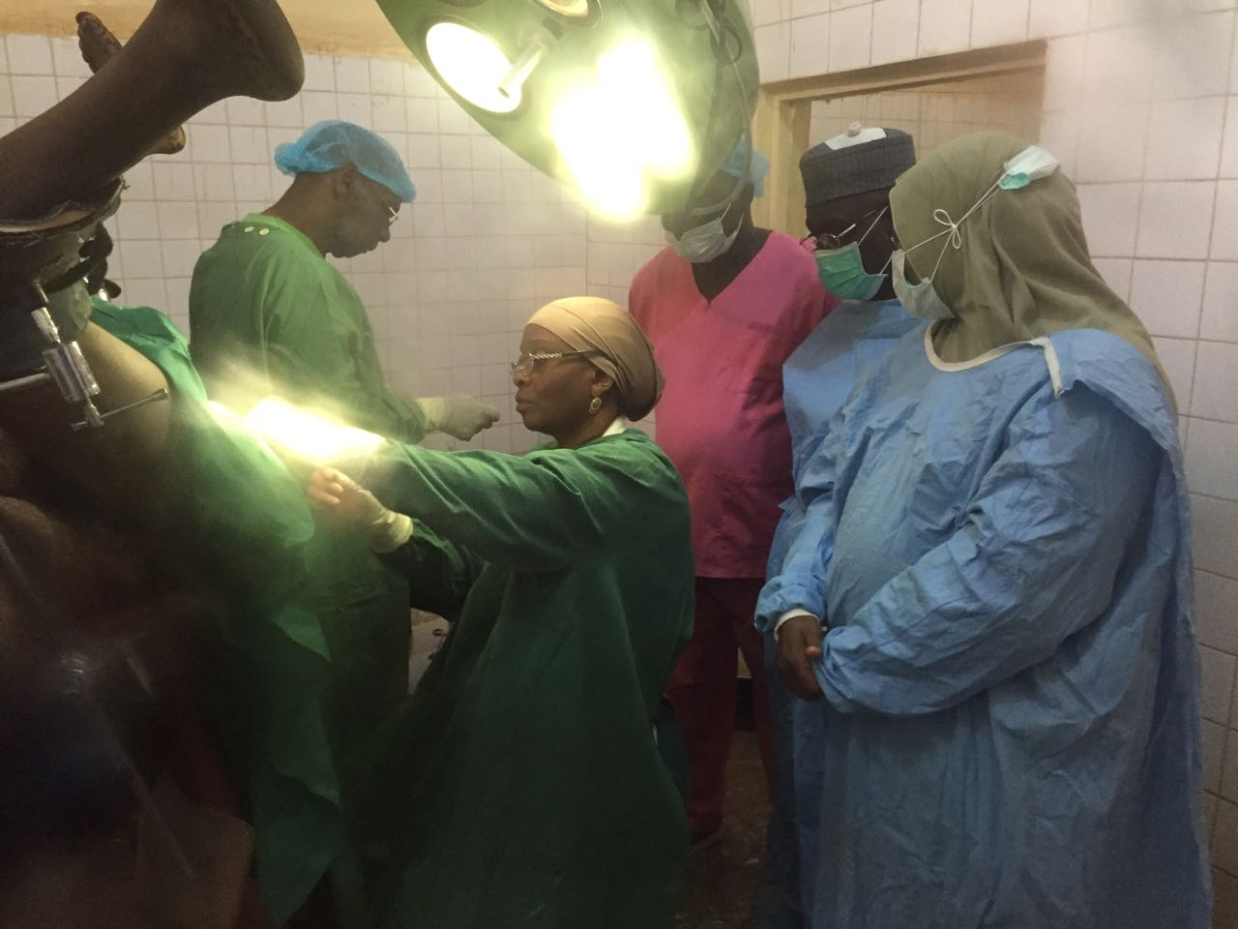
DR SULE, DR HAJARA, DR MAIRO AND TEAM IN THE THEATRE
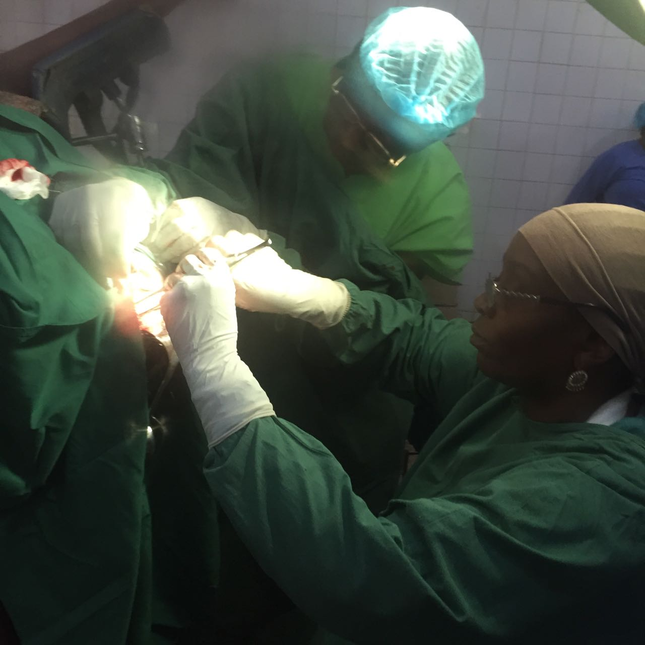
DR. MAIRO AND TEAM IN THE THEATRE
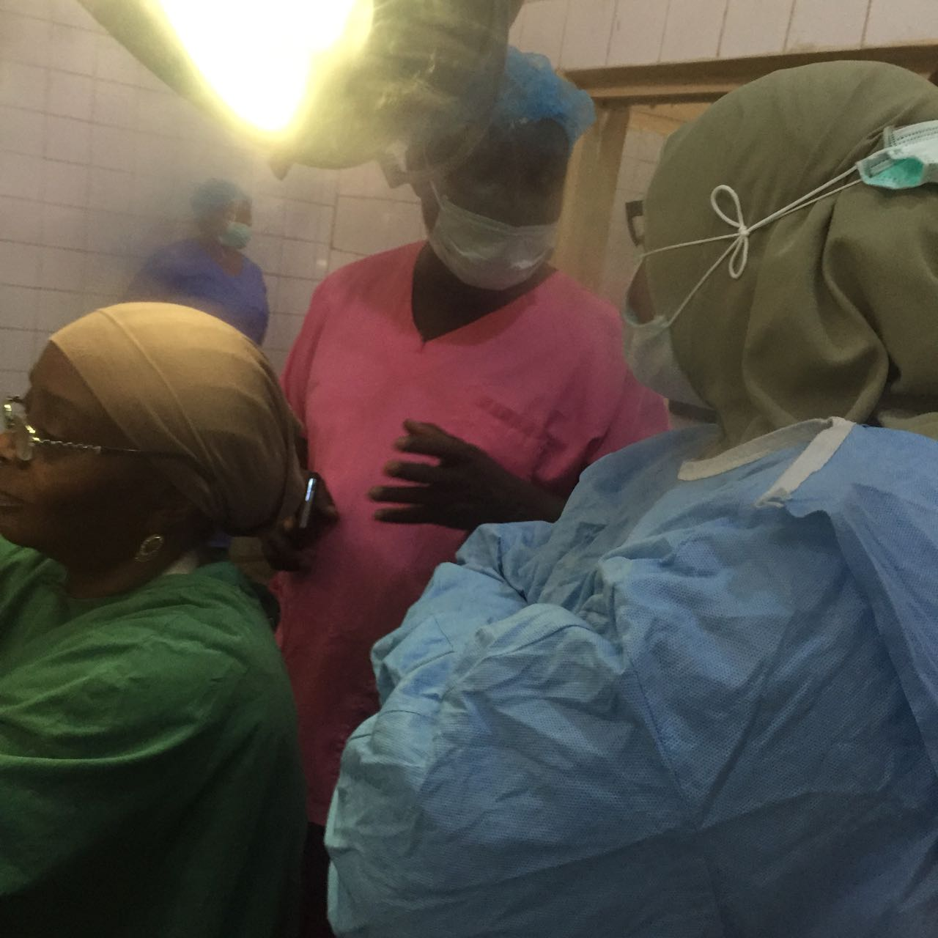
DR MAIRO, DR ABUBAKAR AND DR HAJARA IN THE THEATRE
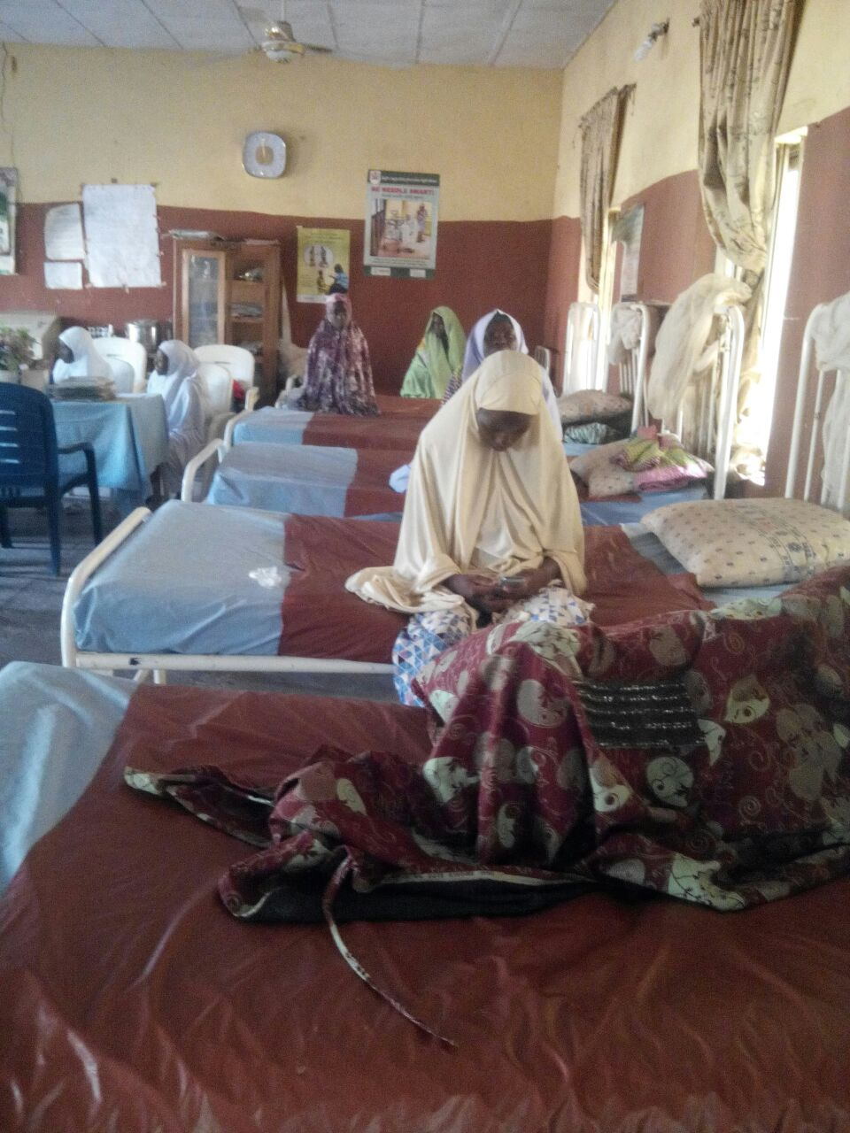
PATIENTS IN THE WARD
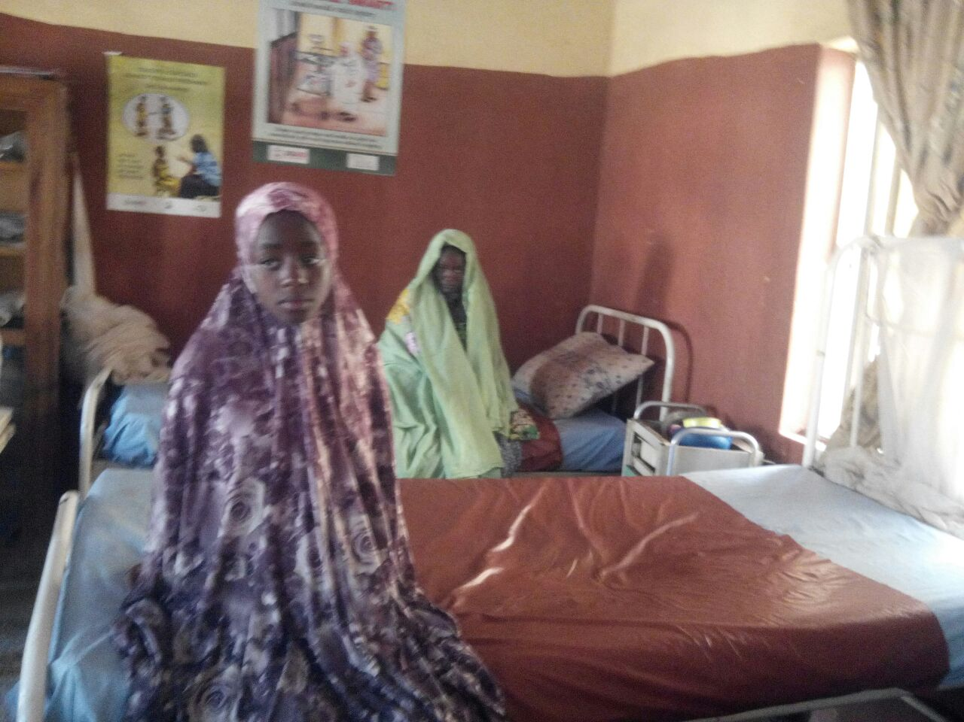
PATIENTS IN THE WARD
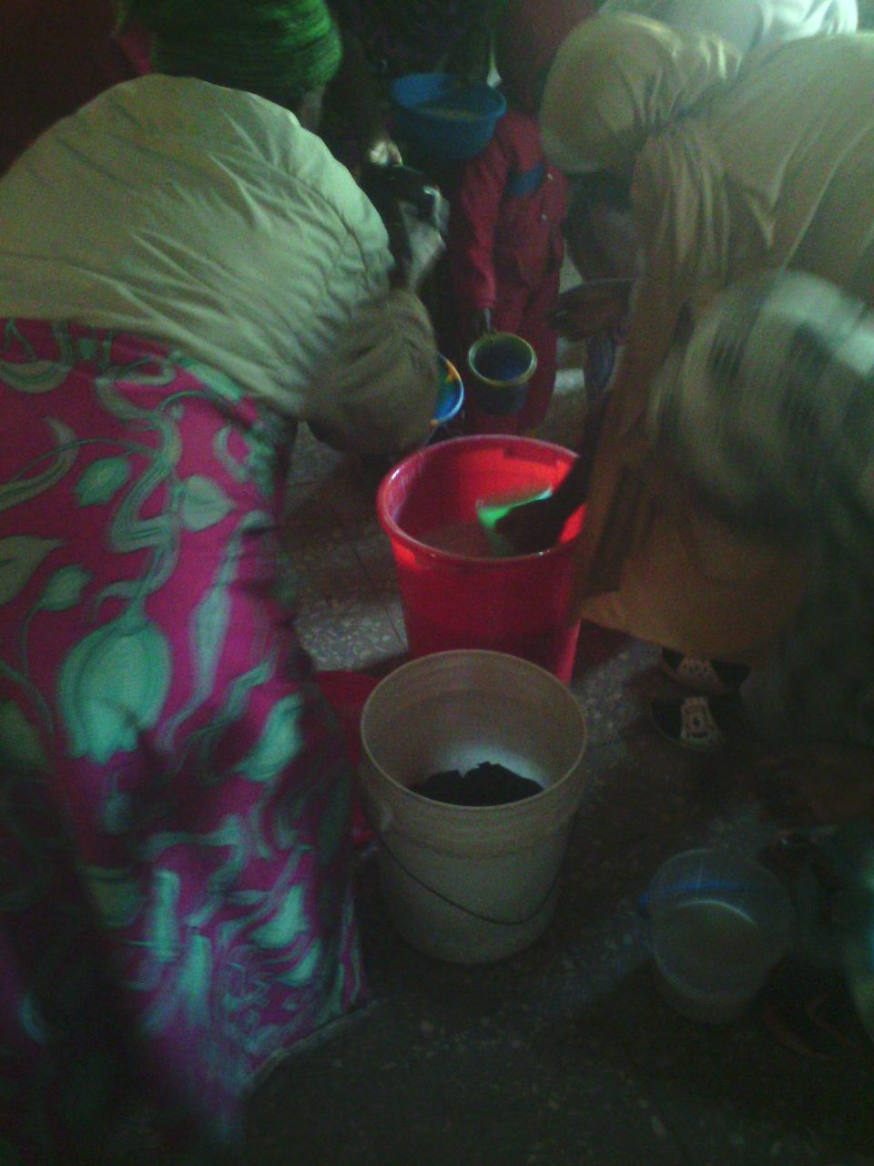
FEEDING TIME
SAVE DIGNITY (IMAN VVF COMMITTEE) MEMBERS:
- DR. I.B SULE (Chairman)
- DR H. UMAR (Secretary)
- MATRON NA’IMAH BALARABE (Member)
- IMAN SOKOTO STATE EXCO MEMBERS
CO-OPTED MEMBERS
- DR. HASSAN IBRAHIM
- ALHAJI UMAR, VICE AMIR SABON WUSE HOSPITAL

DR. H. UMAR 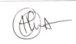
SECRETARY, SAVE DIGNITY/ IMAN COMMITTEE.
27th JANUARY 2017 (11TH JIMADA ULA 1439AH)

